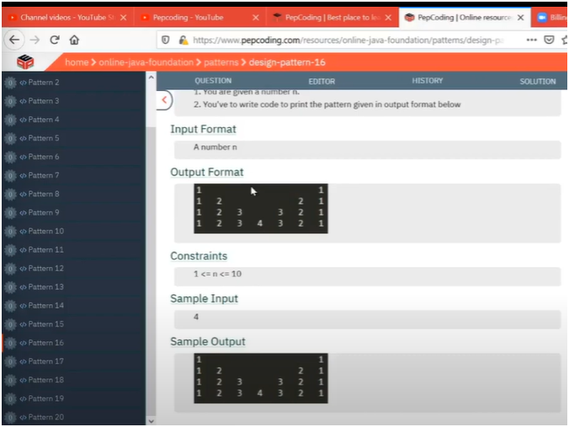

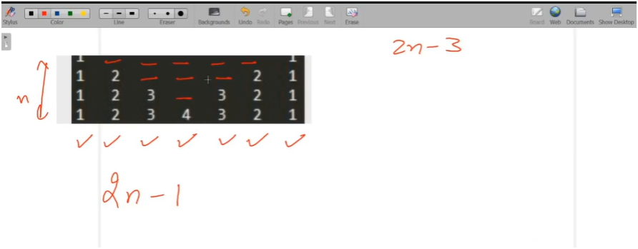

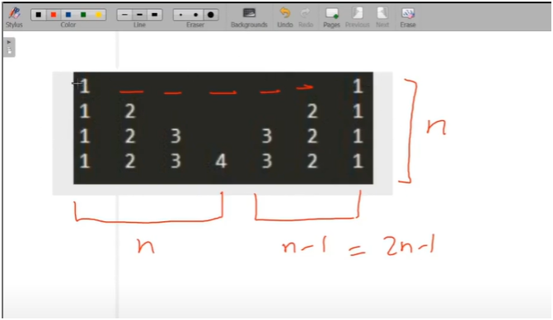

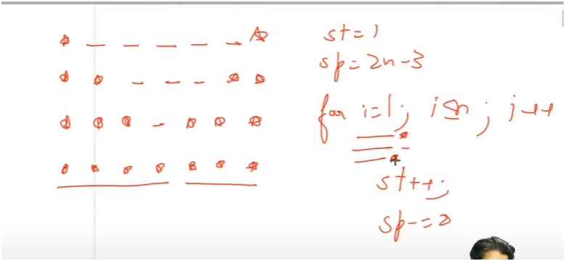

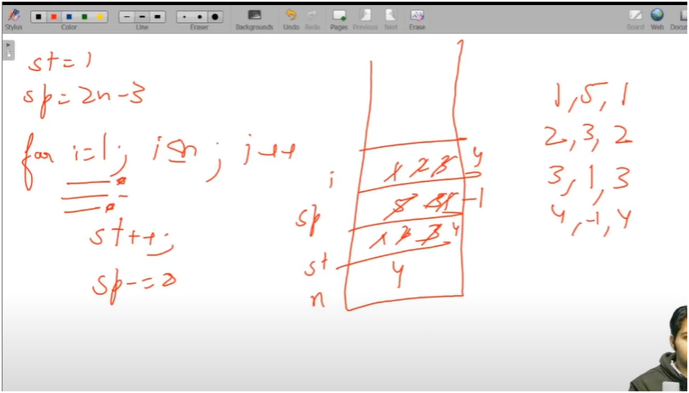

* **IF U SEE CAREFULLY THERE IS A PATTERN IN STARS AS WELL AS SPACES**
* **HERE IF U SEE ON EACH ROW WE FIRST PRINT STARS AND THEN SPACES AND THEN STARS**
* **FIRST BEFORE INCREMENTING AND DECREMENTING WE MUST HAVE IDEA WHAT INTIAL SPACES AND STARS WILL BE STARS WILL BE 1 AND SPACES WILL BE 2 * TOTAL_ROWS-1**
* **WHERE STARS GET INCREMENT WITH 1 AFTER EACH ROW AND SPACES GET DECREMENT BY 2 AFTER EVEY PRINTING**
* **BUT AT LAST ROW WE MUST NEED ONE STAR LESS THEN AT THAT TIME WE MUST KEEP A CHECK LOOP WHERE WE NEED TO SEE IF WE REACH LAST ROW JUST DECREMENT THE STAR BY 1**

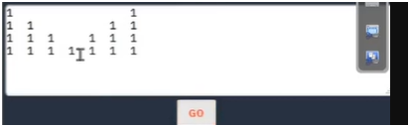

**FIRST PATTERN NOW REPLACE STARS WITH CONSTANT NUMBERS**

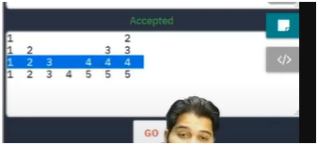

* **IN THIS PATTERN IF WE SEE AT EACH ROW WE NEED TO START WITH 1 AND INCREMENT IT BY 1**
* **MEANS FOR** 
  + **FIRST ROW 1**
  + **SECOND ROW 1 TO 2**
  + **THIRD ROW 1 TO 3**
  + **FOURTH ROW 1 TO 4**
  + **FIFTH ROW 1 TO 5**

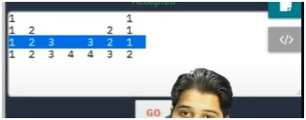

* **IN THIS PATTERN IF WE SEE CAREFULLY** 
  + **IN FIRST LOOP VALUES ARE INCREASING BY 1**
  + **IN SECOND LOOP THERE ARE SPACES**
  + **IN THIR LOOP VALUES ARE AGAIN DECREMENTING BY 1**



**NOW WRITE A CHECK LOOP WHERE AT LAST ROW WE NEED TO DECREMENT VALUE BY 1 AND SPACE BY 1**

**ALGORITHM**

**📌 PATTERN: DOUBLE SIDED MIRRORED NUMBERS (WITH CENTRAL GAP)**

**🎯 OBJECTIVE:**

**\* - Print a pattern where numbers increase on the left side,**

**\* then a big central space, and then numbers decrease symmetrically on the right side.**

**🔢 INPUT:**

**\* - A single integer `total_rows` (e.g., 5)**

**🧠 LOGIC BREAKDOWN:**

**1. Initialize:**

**\* - `star = 1`: Represents how many numbers to print on each side.**

**\* - `spaces = 2 * total_rows - 3`: Central space that decreases as we go down.**

**2. Outer Loop → runs from 1 to `total_rows`:**

**\* - Handles each row of the pattern.**

**3. Inner Loops (inside each row):**

**🔹 First Loop (Left numbers):**

**\* - Starts with `val = 1` and prints `star` increasing numbers (1 to val++)**

**🔹 Second Loop (Spaces in middle):**

**- Prints `spaces` tabs for gap between left and right parts**

**🔹 Conditional Check (if i == total_rows):**

**- On the last row, reduce `star` and `val` so that the middle number is not repeated**

**🔹 Third Loop (Right numbers):**

**- Decrements `val` and prints `star` decreasing numbers (val--)**

**4. Updates After Each Row:**

**\* - `star++`: Increase the count of numbers printed on both sides**

**\* - `spaces -= 2`: Shrink the central gap by 2 spaces**

**\* 📌 KEY CONCEPTS:**

**\* - Symmetry: Mirror logic using increasing and decreasing values**

**\* - Middle Gap: Controlled by a space counter (`spaces`) that reduces over time**

**\* - Edge Case: Avoiding duplicate middle number in the last row using a check (`if i == total_rows`)**